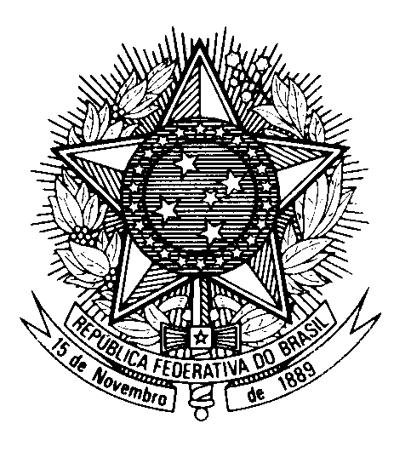

Statement from BRAZIL

Review of Trinidad and Tobago, during the 39th session of the Working Group

on the Universal Periodic Review

(Geneva, 9 November 2021)

Mr. President,
Brazil welcomes the delegation of Trinidad and Tobago to the third cycle of the UPR.
We appreciate Trinidad and Tobago`s efforts to ensure access to justice, specially during COVID-19 pandemic, through the implementation of information and communication technologies solutions to support the Judiciary.
We commend Trinidad and Tobago for the implementation of the "Equal Opportunity Bill", which prevents discrimination and aims at guaranteeing equal treatment for everyone, despite sex, race, origin, religion, marital status or disability.
With a spirit of constructive dialogue, Brazil recommends:
(i) to consider adopting additional legal and policy measures to comply with the Convention relating to the Status of Refugees and its 1967 Protocol, with a view to preventing cases of detention and/or refoulement of asylum seekers; and
(ii) to strengthen measures to combat violence against women by creating specialized police units to investigate these crimes and mitigate impunity.
We wish Trinidad and Tobago a succesful review.

