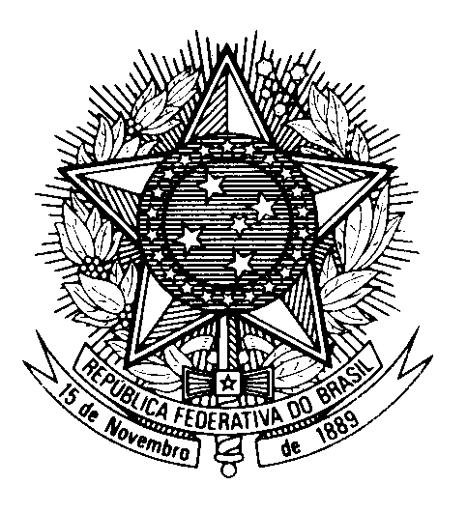

Statement by Second Secretary Pedro Piacesi de Souza,

Permanent Mission of Brazil to the United Nations Office,

in the review of Tanzania, during the 39th session of the Working Group

on the Universal Periodic Review

(Geneva, 5 November 2021)

Madam President,
Brazil welcomes the delegation of Tanzania to the UPR.
We commend Tanzania`s "open doors" policy, which will improve the conditions of the penitentiary system and further enable the press and civil society to have access to detainees.
Brazil appreciates progress achieved in combating violence against women, particularly the continued implementation of the National Plan of Action to end Violence Against Women and Children.
We also recognize the Tanzanian Government`s commitment to fight corruption.
With a constructive spirit, we recommend that Tanzania:
1. takes additional steps to ensure the rights to freedom of expression, peaceful assembly and political participation;
2. continues to strengthen policies and programs aimed at enhancing access to justice and redress concerning violations of the rights of persons in vulnerable situations, including persons with albinism.

Thank you.

