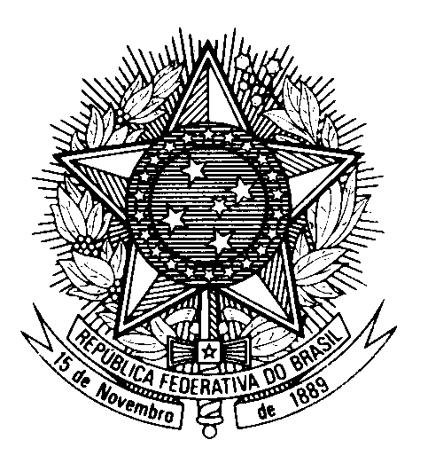

Statement of BRAZIL

39th session of the 3rd cycle of the Universal Periodic Review of Tajikistan

(Geneva, 4 November 2021)

Mr. President,
Brazil welcomes Tajikistan to the third cycle of the UPR. We commend Tajikistan’s amnesty law, approved on the occasion of the 30th anniversary of Independence. We acknowledge the release of prisioners in this context, which contribute to reducing prison accupation rate in the long term, and recommend that the measure be extended to political prisioners.
2. We also welcome the country’s accession to the Convention on the Rights of Persons with Disabilities.
3. With a constructive spirit, Brazil recommends:
(i) to consider adopting new legal and policy measures that foster an enabling environnment for civil society organizations in their work for upholding human rights, especially by guaranteeing their right to freedom of peaceful assembly and association; and
(ii) to consider revising its national legislation on the right to freedom of religion and belief to enhance compliance with international human rights law, by securing everyone the right to manifest one’s religion or belief, regardless of their faith.
We wish Tajikistan a succesful review.

