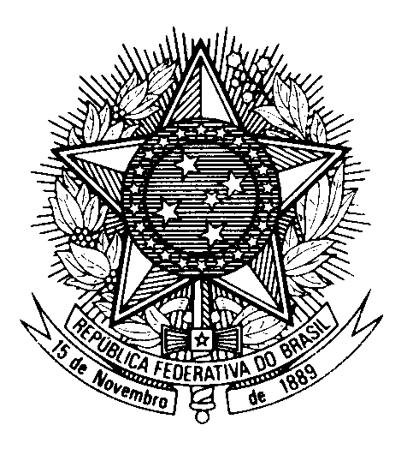

Statement by Ambassador Tovar da Silva Nunes,

Permanent Representative of Brazil to the United Nations Office,

in the review of Suriname, during the 39th session of the Working Group

on the Universal Periodic Review

(Geneva, 1st November 2021)

Madam President,

Brazil welcomes the delegation of Suriname to the UPR.

Brazil commends progress achieved since Suriname’s last review, such as in building skills in the collection and analysis of gender-related data, which contributes to the implementation of SDG 5.

While welcoming Suriname’s efforts to expedite the ratification of the Convention against Torture and Other Cruel, Inhuman or Degrading Treatment or Punishment, Brazil encourages it to conclude this process and consider ratifying the Optional Protocol on the Convention on the Elimination of All Forms of Discrimination against Women.

Brazil has the honour to make the following recommendations:
1) to continue to strengthen its child protection systems, including by further implementing its integrated child protection network (IKBen) and considering establishing specialized courts and police units for child protection;
2) to take additional steps to prevent and combat trafficking in persons, such as creating specific shelters for victims, with a particular focus on women and girls from Amerindian and Maroon communities.

We wish Suriname a successful review.

Thank you

