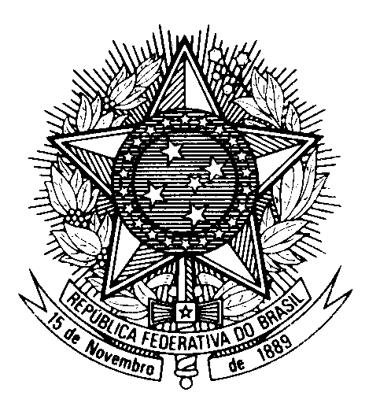

Statement by Minister-Counsellor Christiano Sávio Barros Figueirôa,

Brazil’s Permanent Mission to the United Nations Office,

in the review of Saint Vincent and the Grenadines, during the 39th session of the Working Group

on the Universal Periodic Review

(Geneva, 3 November 2021)

Madam President,

Brazil welcomes Saint Vincent and the Grenadines to the UPR.
We commend the country`s efforts to align its socioeconomic development plan with the 2030 Agenda, especially aiming at attaining SDGs 1 and 5.
Brazil welcomes Saint Vincent and the Grenadines` poverty alleviation programs, the creation of the National Child Rights Committee and the significant improvement achieved in ensuring a timely and universal birth registration system.
While recognizing that the country has established a "de facto" moratorium on the application of the death penalty, Brazil encourages pursuing a formal abolition.
With a constructive spirit, Brazil wishes to make the following recommendations:
1) to consider revising its immigration laws, including by decriminalizing irregular entry and adjusting terminology on migrant children and persons with disabilities; and
2) to redouble efforts to curb domestic and sexual violence and abuse, as well as to consider enacting legislation criminalizing sexual harassment and discrimination based on sexual orientation and gender identity.
We wish Saint Vincent and the Grenadines a successful review.
Thank you.

