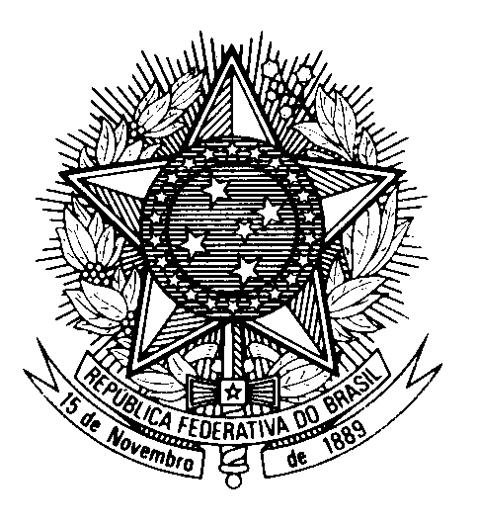

Statement by Secretary Wallace Medeiros de Melo Alves,

Brazil’s Permanent Mission to the United Nations Office,

in the review of Papua New Guinea, during the 39th session of the Working Group

on the Universal Periodic Review

(Geneva, 4 November 2021)

Madam President,
Brazil welcomes Papua New Guinea to the UPR.
We commend the country for its policies and actions regarding the fight against HIV/AIDS, especially its decision to join the Global Partnership for Action to Eliminate All Forms of HIV-related Stigma and Discrimination.
We commend Papua New Guinea`s legal protections concerning the ability of citizens to enforce a wide set of human rights through petitions to the national court, as provided for in the country`s constitution. We encourage Papua New Guinea to continue eliminating practical barriers for access to justice, including by expanding legal aid and information about rights and legal services.
While praising that Papua New Guinea has "de facto" suspended death penalty since 1954, Brazil encourages the country to consider a formal abolition.
Brazil has the honour to make the following two recommendations:
1) to take additional steps to enhance the protection of the rights of refugees and asylum seekers;
2) to consider reviewing current legislation on access to information with the aim of strengthening, both online and offline, the right to privacy, to freedom of expression and to peaceful assembly and association.
Thank you

