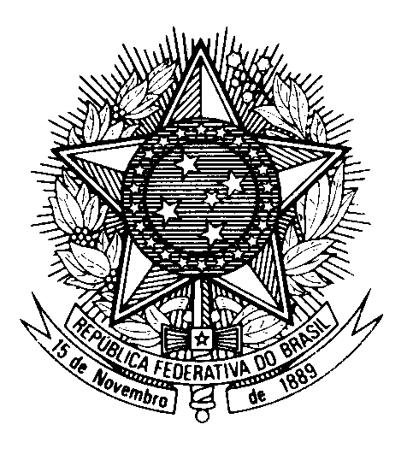

Statement by Ambassador Tovar da Silva Nunes,

Permanent Representative of Brazil to the United Nations Office,

in the review of Ireland, during the 39th session of the Working Group

on the Universal Periodic Review

(Geneva, 10 November 2021)

Madam President,

Brazil welcomes the delegation of Ireland to the UPR.
We commend the final report of the Commission of Investigation into Mother and Baby Homes, which formed the basis for restorative action for victims, as well as the work of the Irish Human Rights and Equality Commission to promote and protect human rights.
We encourage Ireland to continue to improve its child protection system, particularly for children belonging to ethnic minority groups.

With a constructive spirit, we recommend:
1. to take measures to ensure adequate treatment of unadmitted foreigners and asylum seekers, including by providing them with accommodation in appropriate facilities; and
2. to continue to take steps to incorporate the International Convention on the Elimination of All Forms of Racial Discrimination into the domestic legal order.

Thank you

