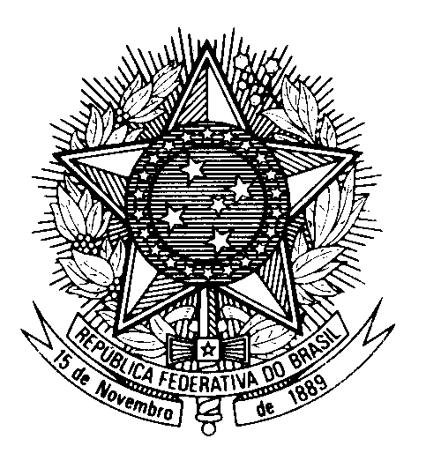

Statement by Ambassador Tovar da Silva Nunes,

Permanent Representative of Brazil to the United Nations Office,

in the review of Hungary, during the 39th session of the Working Group

on the Universal Periodic Review

(Geneva, 2 November 2021)

Madam President,

Brazil welcomes the delegation of Hungary to the UPR.
We commend Hungary for its commitment to prioritize the protection of families, particularly with children, and praise support measures such as monthly allowances and benefits. We also welcome the policies to improve the economic conditions of young workers and retired persons.
We highly appreciate Hungary’s efforts to scale up its ODA, which contributed to 550 development projects in 110 countries in 2020.
With a constructive spirit, we recommend:
1. to take additional measures to address the humanitarian challenges of migrants and asylum-seekers, including with regards to their integration in society;
2. to continue to combat discrimination against the Roma community, particularly women and children, and promote their full social integration into the community.

Thank you.

