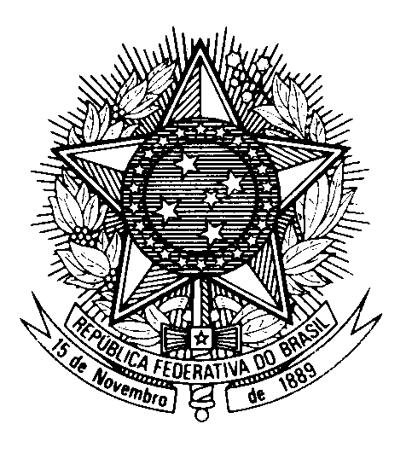

Statement by Ambassador Tovar da Silva Nunes,

Permanent Representative of Brazil to the United Nations Office,

in the review of Greece, during the 39th session of the Working Group

on the Universal Periodic Review

(Geneva, 1 November 2021)

Brazil welcomes the delegation of Greece to the UPR.
We commend Greece for the creation of the National Council against Racism and Intolerance and the adoption of the National Action Plan against Racism 2020-2023.
We also welcome the efforts to combat gender-based violence, with the introduction of a national mechanism to address discrimination faced by women.
We appreciate the specific measures adopted to implement the two recommendations presented by Brazil during the second UPR cycle, in 2016.
With a constructive spirit, Brazil recommends:
1. to redouble efforts to address the challenges of securing humanitarian assistance for migrants and asylum seekers, especially women and children;
2. to promote greater participation of women in the political life and public administration in the country.
We wish Greece a successful review.
Thank you.

