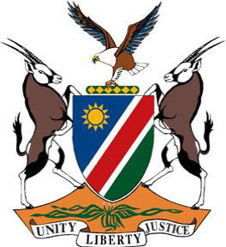
Statement by Tangi Shikongo, Universal Periodic Review of Saint Vincent and the Grenadines, 03 November 2021

Thank you, Madam President,
- Namibia warmly welcomes the Esteemed Delegation of Saint Vincent and the Grenadines and thank them for preparing a comprehensive national report and for the additional information provided today as well as for their commitment to the UPR process.
- We commend Saint Vincent and the Grenadines for the positive human rights impact measures taken during the period under review and in this regard, we are particularly pleased to take note of the adoption in 2015 by Saint Vincent and the Grenadines of a Domestic Violence Law that among other things provides different avenues for victims of domestic violence to seek redress. Namibia also takes note of the fact that the death penalty has not been applied by the State under review since 1993, which means that Saint Vincent and the Grenadines is a de facto abolitionist State.
- There, however, remains room for further improvement and in the spirit of constructive dialogue we make the following recommendations for consideration by Saint Vincent and the Grenadines:
- Ratify the Second Optional Protocol to the International Covenant on Civil and Political Rights, aiming at the abolition of the death penalty; and
- Ratify the Hague Convention on Protection of Children and Cooperation in Respect of Intercountry Adoption of 1993.
- We wish the delegation of Saint Vincent and the Grenadines a successful review.
Thank Madam President,

