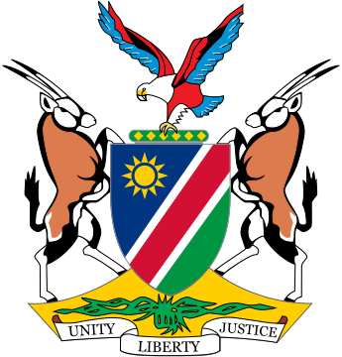

Republic of Namibia
Statement by Mr. Jerry Mika, Third Cycle Universal Periodic Review of Hungary, 02 November 2021

Thank you Madam President,

Namibia welcomes the esteemed delegation of Hungrary and thank them for submitting a comprehensive national report which clearly sets out the measures taken by Hungary to promote, protect and fulfill human rights during the period under review.

We have in particular taken note of the measures taken by Hungary to promote the participation of women in public life, which includes among other things the launching of the Women's Public Leadership Training Program in 2018.

In the spirit of constructive dialogue, we make the following recommendations for consideration by Hungary:

1. Ratify the Council of Europe Convention on Preventing and Combating Violence against Women and Domestic Violence;

2. Develop a national action plan to prevent and address all forms of violence against children.

We wish the delegation of Hungary a successful review.

