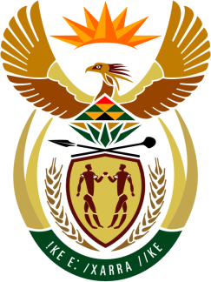

SOUTH AFRICAN PERMANENT MISSION

39th SESSION OF THE WORKING GROUP ON THE
UNIVERSAL PERIODIC REVIEW

Review of The UNITED REPUBLIC OF TANZANIA

5 November 2021

VIRTUAL (ZOOM PLATFORM)
(70 seconds)

Check against delivery

Madam President,

South Africa welcomes the Honourable Prof. Kabudi, Minister for Constitutional and Legal Affairs and the distinguished delegation of the United Republic of Tanzania to this UPR Session.

My delegation welcomes the Government’s efforts to facilitate access to justice, including through the enactment of the Legal Aid Act of 2017 and the decision, in February 2021, that adopted Swahili as a legal language.

In order to ensure progress in promoting and protecting human rights, South Africa wishes to respectively recommend that the United Republic of Tanzania:

- Continue to strengthen measures in combating violence against women and girls and fully implement the National Plan of Action on Violence against Women and Children;

- Enhance measures to prevent discrimination against all vulnerable groups, including persons living with HIV and persons from the LGBTQI community; and

- Ratify all outstanding international human rights treaties it has committed to.

South Africa wishes the United Republic of Tanzania a successful review.

I thank you.

