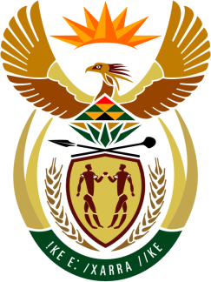

SOUTH AFRICAN PERMANENT MISSION
TO THE UNITED NATIONS
AND OTHER INTERNATIONAL ORGANISATIONS

UNIVERSAL PERIODIC REVIEW

10 november 2021

PALAIS DES NATIONS

Review oF ireland

VIRTUAL (ZOOM PLATFORM)
(65 seconds)

Check against delivery
SPEAKER 96

Madam President,

South Africa welcomes the delegation of Ireland to this UPR Session.

My delegation commends the Irish Government on the establishment of the independent National Anti-Racism Committee
in 2020 to draw up a National Action Plan Against Racism (NAPAR) for Ireland. The work of the Committee is envisioned to strengthen the Irish Government’s approach to combating individual and institutional racism.
South Africa respectfully wishes to make the following recommendations:
- Ratify Optional Protocol to the Convention against Torture and other Cruel, Inhuman or Degrading Treatment or Punishment. (OP-CAT),

- Ratify the Optional Protocol to the International Covenant on Economic, Social and Cultural Rights,

- Develop a national housing strategy to generate affordable housing and combat racial discrimination, with particular attention paid to the needs of vulnerable communities, including Travellers, Roma, migrants, and refugees.

South Africa wishes Ireland a successful review.

I thank you

