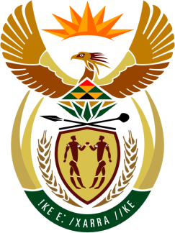

SOUTH AFRICAN PERMANENT MISSION
TO THE UNITED NATIONS
AND OTHER INTERNATIONAL ORGANISATIONS

39th SESSION OF THE WORKING GROUP ON THE
UNIVERSAL PERIODIC REVIEW

Review of ESWATINI

08 NOVEMBER 2021

VIRTUAL (ZOOM PLATFORM)
(85 seconds)

Check against delivery

Madam President,

South Africa welcomes the Honourable Pholile Paulette Dlamini-Shakantu, Minister of Justice and Constitutional Affairs and the distinguished delegation of Eswatini to this UPR Session.

My delegation commends Eswatini’s enactment of the Sexual Offences and Domestic Violence (SODV) Act No. 15 of 2018 and welcomes the strategy, plan of action and guidelines to address gender-based violence.

South Africa respectfully wishes to make the following recommendations:

- Accelerate the implementation of the Sexual and Domestic Violence Act to ensure substantive protection of women from sexual and domestic violence, particularly in the context of COVID-19.

- Finalise the review of the Marriage Act which will fix the marriageable age to 18 from 16 for both males and females.

- Continue taking measures to improve the functioning of the education system, allow pregnant girls access to education and make education free and compulsory for 12 years of schooling, currently only primary school education is free.

- Repeal laws that do not allow safe abortions, affordable contraceptives, or reproductive rights.

South Africa wishes Eswatini a successful review.

I thank you.

