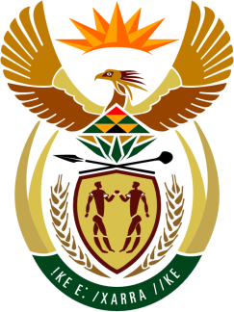

SOUTH AFRICAN PERMANENT MISSION
TO THE UNITED NATIONS
AND OTHER INTERNATIONAL ORGANISATIONS

UNIVERSAL PERIODIC REVIEW

8 november 2021

PALAIS DES NATIONS

Review oF Antigua and Barbuda

VIRTUAL (ZOOM PLATFORM)
(1m55 seconds)

Check against delivery
SPEAKER 35

Madam President,

South Africa welcomes the delegation of Antigua and Barbuda, led by Dr. Vanessa Moe, Crown Solicitor, Ministry of Legal Affairs, to this UPR Session.

My delegation commends Antigua and Barbuda for its ratification, inter alia, of the International Covenant on Civil and Political Rights and the International Covenant on Economic, Social and Cultural Rights,

South Africa respectfully recommends that the Antigua and Barbuda government:

- Ratify the Second Optional Protocol to the International Covenant on Civil and Political Rights.( ICCPR-OP 2);

- Ratify the Optional Protocol to the Convention against Torture and other Cruel, Inhuman or Degrading Treatment or Punishment. (OP-CAT);

- Introduce legislation to prohibit discrimination on the basis of sexual identity or sexual orientation;

- Consider legalising abortion in cases of rape, incest, threat to the life or health of the pregnant woman and severe fetal impairment; decriminalise it in all other cases; and ensure access for women to safe, high-quality and affordable abortion-related care, including post-abortion care in cases of complications resulting from unsafe abortions;

South Africa wishes Antigua and Barbuda a successful review.

I thank you.

