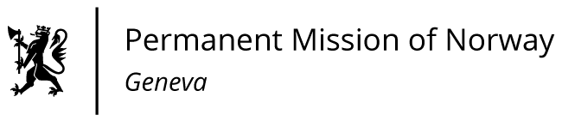

STATEMENT

Universal Periodic Review 39th session
Norway's statement during the 39th UPR session of the Human Rights Council on the human rights situation in Tanzania
as delivered by Ms Anniken Enersen,

Minister-Counsellor Human Rights Norway

Check against delivery
5 November 2021

Madam President,

Norway welcomes the Government of Tanzania’s National Action Plan on Violence against Women and Children, as well as the progress made towards finalizing the text of the National Human Rights Action Plan.
Norway recommends that Tanzania:
  - takes urgent steps to amend legislation to outlaw all forms of child marriage, safeguards women’s rights to sexual and reproductive health and ends violence against women and children;
  - protects children’s rights to access to health and education by abolishing corporal punishment in schools;
  - fully respects and protects the rights to freedom of assembly and freedom of expression, and enshrines in law the right to a safe and enabling environment for human rights defenders, journalists and media workers;

  - approves and implements reforms to strengthen the independence of the judiciary and to strengthen citizens’ access to justice and legal aid;

  - abolishes the death penalty in all circumstances.

Thank you.

