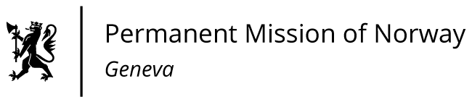

STATEMENT

Universal Periodic Review 39th session
Norway's statement during the 39th UPR session of the Human Rights Council on the human rights situation in Thailand
as delivered by Ms Anniken Enersen,

Minister-Counsellor Human Rights Norway

Check against delivery
2 November 2021

Madam President,
Norway welcomes Thailand's participation in the UPR, and notes that several positive steps have been taken since the previous review, including on the implementation of Thailand´s obligations under the Palermo Protocol on human trafficking.
Norway recommends that Thailand:
- guarantees the rights to freedom of expression, association and peaceful assembly, and protects individuals, including political opponents, from judicial harassment;
- reviews the lèse-majesté law to bring it into conformity with international standards, and to prevent it from being used to silence opponents;
- ensures the protection of human rights defenders, including through prompt and thorough investigation of attacks;
- ensures that the adoption of new NGO-legislation will not prevent or impede civil society organisations from operating securely and freely;
- ratifies OP-CAT and ICPPED and accelerates the enactment of the Act on Torture and Enforced Disappearance.
- Thank you.

