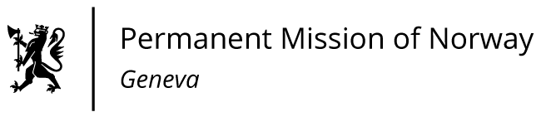

STATEMENT

Universal Periodic Review 39th session
Norway's statement during the 39th UPR session of the Human Rights Council on the human rights situation in Tadsjikistan
as delivered by Ms Jannicke GRAATRUD

Minister, Deputy Permanent Representative Norway

Check against delivery

4 November 2021
Madam President,
Norway welcomes Tajikistan’s participation in the UPR. However, we remain deeply concerned about developments in the human rights situation in Tajikistan.
Norway recommends that Tajikistan:
- ensures media freedom and pluralism, including by abolishing the recently introduced legislation on media licensing;
- ensures that lawyers are guaranteed full independence and safety, in law and in practice, to carry out their legitimate duties without any harassment, undue interference or fear of arbitrary criminal prosecution or other retaliatory measures;
- introduces legislation to criminalise all forms of gender-based violence, including domestic violence, marital rape and sexual assault within and outside marriage, and ensures that this legislation is enforced;
- takes further measures to eradicate torture and ill treatment, including ratifying the Optional Protocol to the Convention against Torture and other Cruel, Inhuman or Degrading Treatment.
Thank you.

