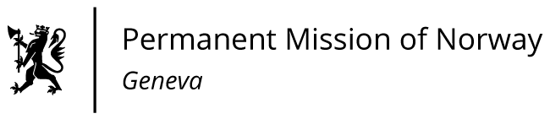

STATEMENT

Universal Periodic Review 39th session
Norway's statement during the 39th UPR session of the Human Rights Council on the human rights situation in Ireland
as delivered by Ambassador Tine Mørch Smith,
Permanent Representative of Norway

Check against delivery
10 November 2021

Madam President,

Norway welcomes Ireland’s participation in the UPR and notes the positive steps taken since its last review, including Ireland’s introduction and speedy implementation of the law on abortion.

Norway remains concerned about the delay in ratifying the Optional Protocol to the Convention against Torture.

Norway recommends that Ireland:
  - ratifies the Optional Protocol to the Convention against Torture and ensure that mentally ill individuals in prison have access to psychiatric care;

  - follows up the National Traveller and Roma Inclusion Strategy 2017-2021 to address the intersectional racism and discrimination experienced by Traveller and Roma women;

  - develops a strategy to address the marginalisation of people with disabilities;

  - changes the wording of Article 41.2 of the Irish Constitution to make it gender neutral.

Thank you.

