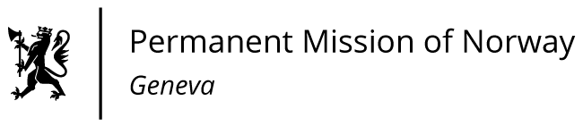

STATEMENT

Universal Periodic Review 39th session
Norway's statement during the 39th UPR session of the Human Rights Council on the human rights situation in Hungary
as delivered by Ambassador Tine Mørch Smith,
Permanent Representative of Norway

Check against delivery
2 November 2021

Madam President,
Norway welcomes Hungary’s participation in the UPR.
Norway recommends that Hungary:
- takes steps to protect freedom of expression through media pluralism, including by promoting the political independence of the media regulatory authority;

- ensures that civil society organisations can operate freely, without discrimination or undue restriction;

- repeals the legislation banning the “promotion of homosexuality” among minors, and enacts legislation to protect LGBTI persons from discriminatory practices;

- strengthens measures to combat hate speech and hate crime, especially when targeted towards LGBTI persons, asylum seekers, migrants and Roma.
Thank you.

