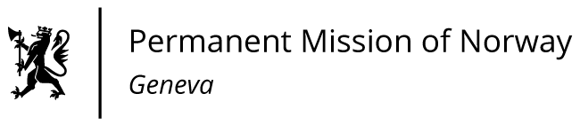

STATEMENT

Universal Periodic Review 39th session
Norway's statement during the 39th UPR session of the Human Rights Council on the human rights situation in Greece
as delivered by Ms Jannicke GRAATRUD

Minister, Deputy Permanent Representative Norway

Check against delivery
1 November 2021

Madam President,

Norway welcomes Greece’s participation in the UPR and commends the positive steps taken since its last review, including the creation of the Special Secretariat for the Protection of Unaccompanied Minors in the Ministry of Migration and Asylum.

Norway recommends that Greece:
- develops a long-term strategy to ensure equal access and quality of education for child asylum-seekers, refugees, migrants and other vulnerable children;

- promptly and fully investigates reports of breaches of the principle of non-refoulement and allegations of summary forced returns of migrants at the EU border between Greece and Turkey, including acts of violence or ill treatment that may have occurred during such incidents;

- continues to improve the criminal justice system and takes measures to address arbitrary deprivation of liberty;

- implements the National Action Plan Against Racism and Intolerance 2020-2023 to address hate crimes and hate speech directed against members of vulnerable groups.

Thank you.

