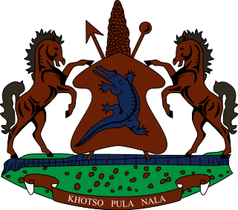

STATEMENT BY THE KINGDOM OF LESOTHO DURING THE 3rd UPR REVIEW OF TANZANIA

05 NOVEMBER, 2021

Thank you, Madam President,
Lesotho welcomes the delegation of Tanzania to the Working Group. We take note of the steps taken by Tanzania in various areas to promote and protect human rights of its people. We applaud Tanzania for fulfilling their reporting obligations under CRPD, CRC and CEDAW. Further, we comment them for addressing child labour by developing a National Strategy on Elimination of Child Labour of 2018-2022.
At this point, we wish to make the following recommendations for consideration by Tanzania: 1. to continue efforts to combat discrimination and non-equality against women, especially on issues relating to marriage and inheritance. 2. To strengthen measures to safeguard health rights of women, particularly on issues relating to prenatal and postnatal care of pregnant women.
Finally, we wish Tanzania every success with this UPR cycle.

