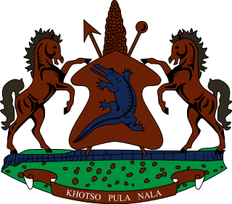

STATEMENT BY THE KINGDOM OF LESOTHO DURING THE 3rd UPR REVIEW OF ESWATINI

08 NOVEMBER, 2021

Thank you, Madam President,
Lesotho extends a warm welcome to the delegation of Eswatini to the Working Group and thank them for the presentation of their National Report. We applaud Eswatini for efforts made to eliminate discrimination and inequality against women, by incorporating sections in the Constitution which protect and promote the rights of women. We further note the steps taken to curb domestic violence by developing and implementing a
National Strategy and Action Plan to End Violence (2017-2022).

In the spirit of cooperation and constructive approach, we wish to make the following two recommendations for consideration by the delegation of Eswatini: 1. To continue efforts to solicit funds for the functioning of the Anti-corruption Commission; 2. To beef up measures to address overcrowding in detention centers.

We wish Eswatini every success with this UPR cycle.

