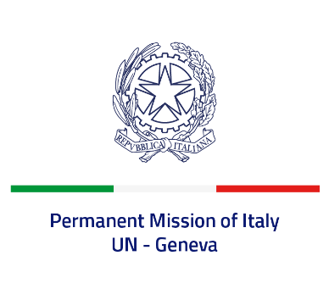
Check against delivery
UPR 39 – Trinidad and Tobago
Tuesday 9 November 2021, 9:00 – 12:30
Delivered by: Minister Marie Sol Fulci, Deputy Permanent Representative of Italy

(Focal point: Daniele Borrelli, Counsellor)
Thank you, Madam President.

We thank the distinguished delegation of Trinidad and Tobago for their national report and presentation.

Italy welcomes the fact that Trinidad and Tobago maintained a de facto moratorium on the death penalty. We also welcome that the Domestic Violence Act was amended in 2020 to include several improvements aimed at widening its scope.
Italy seizes this opportunity to offer Trinidad and Tobago the following recommendations:

- Ratify the Convention against Torture and Other Cruel, Inhuman or Degrading Treatment or Punishment.
- Continue the efforts to ensure full and effective implementation to the “Domestic Violence Act”.
- Take further steps to combat all forms of violence, abuses and discrimination based on sexual orientation and gender identity.
- Establish a de jure moratorium on the death penalty and ratify the Second Optional Protocol to the ICCPR aiming at the abolition of the death penalty.
- Align national legislation on refugees and asylum seekers to international obligations and improve efforts to address human trafficking.

We wish Trinidad and Tobago a successful review.

I thank you.

