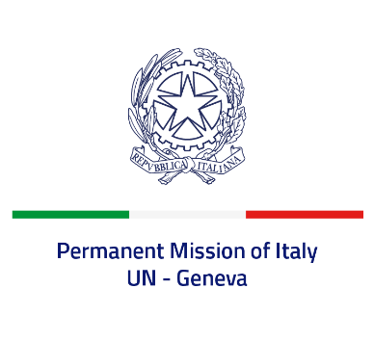
Check against delivery
UPR 39 - Thailand
Wednesday 10 November 2021, 9:00 - 12:30

Delivered by: Ambassador Gian Lorenzo Cornado, Permanent Representative of Italy

(Focal point: Angela Zanca, First Secretary)

Thank you, Madam President.

We thank the distinguished delegation of Thailand for their national report and presentation.

Italy welcomes the adoption of the National Action Plan on Business and Human Rights in 2019, as well as the efforts made to promote gender equality and women empowerment.

Italy seizes this opportunity to offer Thailand the following recommendations:

- Consider all necessary steps to adopt a de jure moratorium of capital executions, with a view to fully abolishing the death penalty;
- Create a safe and enabling environment to exercise the rights to peaceful assembly and freedom of expression and prevent attacks and intimidation against human rights defenders;
- Align the “Draft Prevention and Suppression of Torture and Enforced Disappearance Act” with Thailand’s obligations under international law;
- Take further measures to combat all forms of violence and discrimination against women and children, including domestic violence.

We wish Thailand a successful review.

I thank you.

