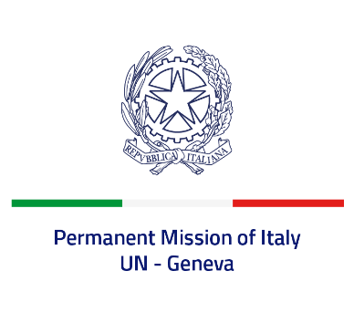
Check against delivery
UPR 39 – Tajikistan
Thursday 4 November 2021, 14:30 – 18:00
Delivered by: Minister Marie Sol Fulci, Deputy Permanent Representative of Italy

(Focal point: Daniele Borrelli, Counsellor)
Thank you, Madam President.
We thank the distinguished delegation of Tajikistan for their national report and presentation.
Italy welcomes the signing of the Convention on the Rights of Persons with Disabilities and the National Action Plan to prepare its ratification. We also welcome the commitment to implement the recommendations made by United Nations bodies, including through the adoption of specific national action plans.
Italy seizes this opportunity to offer Tajikistan the following recommendations:
- Align national legislation to international standards to effectively guarantee freedom of expression, media freedom and pluralism, as well as freedom of religion or belief.
- Strengthen measures to prevent episodes of torture and enforced disappearances.
- Take concrete measures to combat all forms of discrimination and violence, including domestic violence, based on gender, sexual orientation and gender identity.
- Continue the process to adhere to the main international instruments on human rights, in particular ratify the Convention on the Rights of Persons with Disabilities signed in 2018.
- Ratify the second Optional Protocol to the ICCPR and fully abolish the death penalty from the Penal code.

We wish Tajikistan a successful review.
I thank you.

