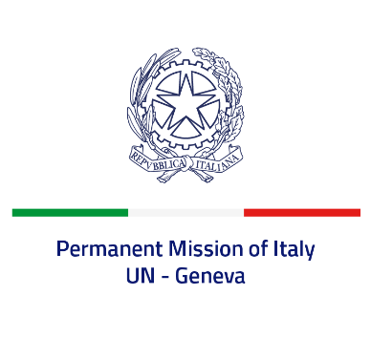
Check against delivery
UPR 39 – SAINT VINCENT AND THE GRENADINES
Wednesday 3 November 2021, 14:30 – 18:00
Delivered by: Minister Marie Sol Fulci, Deputy Permanent Representative of Italy

(Focal point: Daniele Borrelli, Counsellor)
Thank you, Madam President.

We thank the distinguished delegation of Saint Vincent and the Grenadines for their national report and presentation.

Italy welcomes the fact that Saint Vincent and the Grenadines maintained a de facto moratorium on the death penalty. We also welcome the progress in harmonizing the domestic legislation with the Convention on the Rights of the Child as well as the establishment of the National Child Rights Committee.
Italy seizes this opportunity to offer Saint Vincent and the Grenadines the following recommendations:

- Adopt a de jure moratorium on executions and adhere the second optional protocol to the international Covenant on civil and political rights on the abolition of the death penalty, with a view to formally abolishing the death penalty;
- Strengthen measures to protect women, girls and children from violence and sexual exploitation and abuse;
- Decriminalize consensual adult same sex relations and combat discrimination against LGBTI persons;
- Intensify efforts to guarantee freedom of association and assembly.

We wish Saint Vincent and the Grenadines a successful review.
I thank you.

