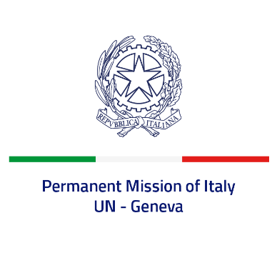
Check against delivery
UPR 39 - Ireland
Wednesday 10 November 2021, 14:30 - 18:00

Delivered by: Ambassador Gian Lorenzo Cornado, Permanent Representative of Italy

(Focal point: Angela Zanca, First Secretary)

Thank you, Madam President.

We thank the distinguished delegation of Ireland for their national report and presentation.

Italy commends Ireland for the ratification of both the Convention on the Rights of Persons with Disabilities in 2018 and the Istanbul Convention in 2019, as recommended by Italy during the last review.

We also praise Ireland’s engagement to tackle domestic, sexual and gender-based violence, namely through the adoption of the Second National Strategy 2016-2021 and the approval of the Domestic Violence Act in 2018.

Italy seizes this opportunity to offer Ireland the following recommendations:

- Ratify the International Convention for the Protection of all Persons from Enforced Disappearance signed in 2007;

- Ratify the Optional Protocol to the Convention on the Rights of the Child on the sale of children, child prostitution and child pornography signed in 2000.

We wish Ireland a successful review.

I thank you.

