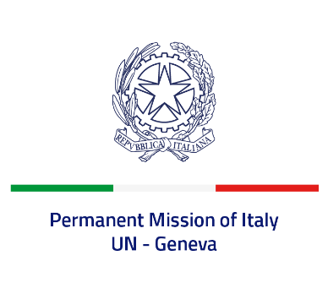
Check against delivery
UPR 39 – Hungary
Tuesday 2 November 2021, 14:30 – 18:00

Delivered by: Ambassador Gian Lorenzo Cornado, Permanent Representative of Italy

(Focal point: Daniele Borrelli, Counsellor)

Thank you, Madam President.

We thank the distinguished delegation of Hungary for their national report and presentation.

Italy welcomes Hungary’s commitment to ensuring the implementation of its international obligations through its national legal system. We particularly welcome the adoption of a protocol-based norm in order to provide uniform, effective and professional law enforcement responses to hate crimes.
Italy seizes this opportunity to offer Hungary the following recommendations:

- Consider ratifying the International Convention for the Protection of all Persons from Enforced Disappearance and the Optional Protocol to the International Covenant on Economic, Social and Cultural Rights and the “Istanbul Convention” of the Council of Europe;
- Take concrete initiatives – also at a legislative level - to ensure actual press freedom and freedom of expression;
- Implement measures to guarantee the independence of the judiciary;
- Take concrete measures to combat all forms of discrimination, including when based on religion or belief, ethnicity and sexual orientation, in compliance with international and European obligations. Consider revising legislative provisions that could result in discriminations.

We wish Hungary a successful review.
I thank you.

