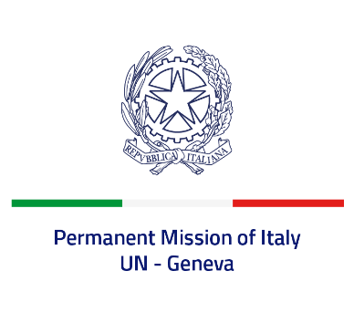
Check against delivery
UPR 39 – Greece
Monday 1 November 2021, 9:00 – 12:30

Delivered by: Ambassador Gian Lorenzo Cornado, Permanent Representative of Italy

(Focal point: Daniele Borrelli, Counsellor)

Thank you, Madam President.

We thank the distinguished delegation of Greece for their national report and presentation.

Italy commends Greece for the ratification of the Council of Europe Convention on Preventing and Combating Violence against Women and Domestic Violence (Istanbul Convention). We welcome the adoption of the National Action Plans on the rights of Persons with Disabilities, on the Rights of the Child, against Racism and Intolerance as well as the first National Action Plan on Women, Peace and Security. We also welcome the measures on promoting substantive gender equality and preventing and combating gender-based violence and the commitment to protect the rights of LGBTI persons.
Italy seizes this opportunity to offer Greece the following recommendations:

- Sign and ratify the Optional Protocol to the International Covenant on Economic, Social and Cultural Rights;

- Continue stepping up efforts to prevent gender-based violence against women, including domestic violence, and to promote women empowerment.

We wish a successful review.

I thank you.

