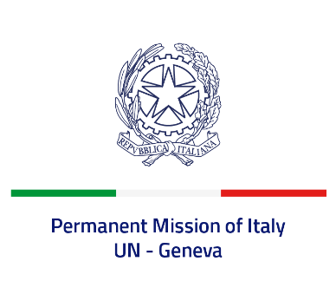
Check against delivery
UPR 39 – Antigua and Barbuda
Monday 8 November 2021, 14:30 – 18:00
Delivered by: Ambassador Gian Lorenzo Cornado, Permanent Representative of Italy

(Focal point: Daniele Borrelli, Counsellor)
Thank you, Madam President.

We thank the distinguished delegation of Antigua and Barbuda for their national report and presentation.
Italy commends Antigua and Barbuda for the ratification of the International Covenant on Civil and Political Rights and the International Covenant on Economic, Social and Cultural Rights. We welcome the adoption of the Disabilities and Equal Opportunities Act of 2017. We also welcome the efforts made to carry out a comprehensive review of existing laws to ensure compliance and harmonization with the provisions of the Convention on the Rights of the Child.
Italy seizes this opportunity to offer Antigua and Barbuda the following recommendations:
- Take further measures to prevent violence against women and girls, including domestic violence, also through awareness-raising campaigns and increasing support to victims.
- Decriminalise consensual adult same sex relations and combat discrimination and violence based on sexual orientation and gender identity.
- Improve the conditions of detention facilities, including hygiene and sanitation.
- Establish a de jure moratorium on the death penalty and ratify the Second Optional Protocol to the ICCPR, with a view to abolishing the death penalty.

We wish Antigua and Barbuda a successful review.

I thank you.

