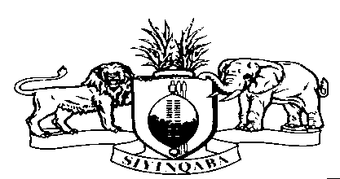
ESWATINI GOVERNMENT

ADOPTION OF THE REPORT ON ESWATINI UPR REVIEW

3RD CYCLE OF THE UNIVERSAL PERIODIC REVIEW
12 NOVEMBER, 2021

Madam President,
Your Excellencies’;
Members of the Troika- France, Libya and Nepal
Member States and Observer States

On behalf of the Government of the Kingdom of Eswatini, may I express our appreciation to all member states for their constructive comments, interventions and recommendations made during the inter-active dialogue on Monday morning. Our profound gratitude is also extended to members of the Troika – France, Libya and Nepal for their diligent facilitation of our review.

A debt of gratitude also goes to the Secretariat of the Office of the High Commissioner for Human Rights (OHCHR), the UPR Secretariat for their meticulous guidance and leadership in the entire series of the session.

On behalf of the Government of Eswatini, I make the commitment to take these recommendations back to the Capital for further deliberations. We will make the time to engage with all the relevant stakeholders and articulate the position of the Kingdom during 49th Session of the Human Rights Council in March 2022.

In conclusion, may I take the opportunity to thank you Madam President and your bureau for the smooth facilitation made during the 39th Session of the Universal Periodic review.

I thank you.

