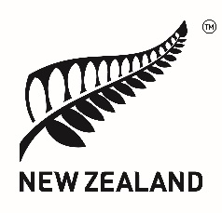 | Human Rights Council  38th session of the Universal Periodic Review  Solomon Islands  Delivered by Permanent Representative Lucy Duncan  10 May 2021

Madam President,

New Zealand welcomes this opportunity for dialogue with Solomon Islands on its human rights record.

New Zealand acknowleges that Solomon Islands has made progress to address violence against women and children and encourages continued momentum in this area, particularly as rates of violence remain high. New Zealand recommends Solomon Islands adopt key recommendations from the 2020 Family Protection Act Review Report.

New Zealand recommends that Solomon Islands address legislative gaps that leave children vulnerable, including criminalising sexual exploitation of children, child pornography, and the sale of girls to foreign workers for sex or marriage.

New Zealand commends Solomon Islands’ commitment to addressing disability issues. We recommend that Solomon Islands ratify and implement the International Convention on the Rights of Persons with Disabilities. We further recommend that Solomon Islands enact laws to prohibit discrimination against persons with physical, sensory, intellectual or mental disabilities.

New Zealand recommends that Solomon Islands moves towards decriminalisation of consensual sexual relations between persons of the same sex. New Zealand also recommends that Solomon Islands introduces legislation prohibiting discrimination against people of diverse sexual orientations and gender identities.

Thank you.

