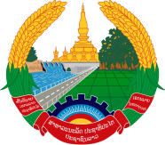
Statement by the Representative of the Lao PDR
At the 38th Session of UPR Working Group
Geneva, 3-14 May 2021
Review of Sierra Leone: 12 May 2021
Madam President,
Laos warmly welcomes the distinguished delegation of Sierra Leone to the UPR session and thanks for its comprehensive report.

Laos takes note of the progress made by Sierra Leone in the promotion and protection of human rights in the country, especially the promotion of gender equality, women empowerment and right to education as well as poverty reduction through the implementation of the recommendations adopted in the previous UPR cycle.

In constructive spirit, Laos wishes to offer following recommendations:

- Continue to implement its Gender Mainstreaming policy to further promote gender parity and women empowerment; and

- Continue its commitment to realise the Poverty Reduction Strategy with a focus on employment creation and income generation for people, including people in rural communities.

We wish Sierra Leone a success in its review.

I thank you, Madam President.

