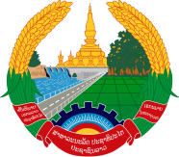
Statement by the Representative of the Lao PDR
At the 38th Session of UPR Working Group
Geneva, 3-14 May 2021

Review of Namibia: 3 May 2021

Madam President,
Laos warmly welcomes the distinguished delegation of Namibia to the UPR session and thanks for its comprehensive report presented today.

Laos would like to commend the progress made by the Government of Namibia in the promotion and protection of human rights, including the implementation of the recommendations adopted in the previous UPR cycle as well as its national measures on the empowerment of girls, boys and women, and the eradication of poverty in the country.

In constructive dialogue, Laos wishes to recommend as follows:

- Continue its efforts in realizing its National Development Plan as to alleviate and eradicate poverty in the country; and

- Continue its endeavour in providing quality and accessible education for all learners, especially learners with disabilities, orphans and vulnerable children.

We wish Namibia every success in the review.

I thank you, Madam President.

