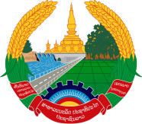
Statement by the Representative of the Lao PDR
At the 38th Session of UPR Working Group
Geneva, 3-14 May 2021
Review of Latvia: 11 May 2021
Madam President,
Laos warmly welcomes the distinguished delegation of Latvia to the UPR session.
Laos wishes to take note of progress made by Latvia in the promotion and protection of human rights in the country, which includes the promotion of women rights, gender equality, rights of persons with disabilities; and prevention of all types of discrimination.
In this connection, Laos wishes to offer the following recommendations:
- Continue to implement its measures to combat all types of discrimination by developing guidelines, education curricula and others, applying principle of diversity and gender equality

- Further strengthen its educational system and various curriculum to ensure that quality education is accessible to all, especially children, persons with disabilities, and persons belonging to ethnic minorities.

Laos wishes Latvia a very successful review.
I thank you, Madam President.

