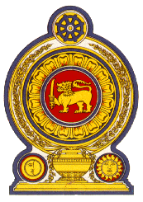

38th Session of the Universal Periodic Review

Review of Denmark, 5th May 2021
Statement by the Democratic Socialist Republic of Sri Lanka

Mr. President,

Sri Lanka thanks the delegation of Denmark and the presentation made.

Sri Lanka appreciates actions taken by Denmark to improve the human rights situation in the country including through measures taken to address issues related to inequality in the labour market and initiatives promoting equal pay.

In a constructive spirit, Sri Lanka recommends that Denmark:

- Strengthens protection for migrant workers including through ratification of the International Convention on the Protection of the Rights of All Migrant Workers and Members of Their Families

- Further strengthens efforts to promote access to healthcare by children and women, particularly those in irregular situations

- Enhance measures to ensure that evictions and rehousing respect human rights standards

We wish Denmark success in its UPR engagement.

