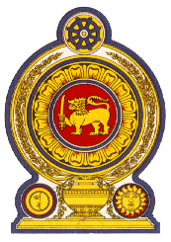

38th Session of the Universal Periodic Review

Review of Namibia – 03 May 2021

Statement by the Democratic Socialist Republic of Sri Lanka

Madam President,

Sri Lanka extends a warm welcome to the delegation of Namibia and appreciates the presentation made.

We commend Namibia’s commitment to promoting the right to education including girls’ education, to effectively combating trafficking in persons, and to addressing challenges faced by persons with disabilities.

We welcome the enactment of the Obsolete Laws Act seeking to repeal outdated or discriminatory legislation, the Combating of Trafficking in Persons Act which seeks to give effect to the United Nations Protocol to Prevent, Suppress and Punish Trafficking in Persons, Especially Women and Children (Palermo Protocol), and the proposed laws to promote legal aid.

Sri Lanka recognizes the challenges identified in Namibia’s UPR report and encourages the United Nations to extend the cooperation requested by Namibia to overcome these challenges.

While recognizing the progress already made, Sri Lanka recommends that Namibia:

- Promotes the right to education including through the implementation of the Basic Education Act of 2020 and maintaining the national budgetary contribution to education;

- Continues national efforts to further improve access to safe drinking water and sanitation; and

- Further advances the right to health by enhancing achievements in preventing maternal and infant mortality and the fight against HIV/AIDS.

We wish Namibia success in its UPR engagement.

