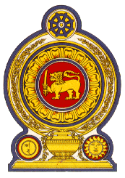

38th Session of the Universal Periodic Review

Review of Mozambique– 04 May 2021

Statement by the Democratic Socialist Republic of Sri Lanka

Mr. President,

Sri Lanka welcomes the delegation of Mozambique and appreciates the comprehensive presentation made to the Council.

Sri Lanka commends the action taken to increase the institutional and response capacity of national human rights institutions, particularly those of the Ombudsman and the National Human Rights Commission engaging in a broader range of issues.

We also appreciate ratification by Mozambique of the Protocol to the Forced Labour Convention, 1930 and measures taken to promote female participation in public life.

While recognizing the progress already made, Sri Lanka recommends that Mozambique:

- Continues working towards universal access to healthcare including through the ‘One district One hospital’ programme;

- Further strengthens efforts to promote the rights of older persons by implementing relevant national laws and policies; and

- Intensifies measures to reduce school dropout rates.

We wish Mozambique success in its UPR engagement.

