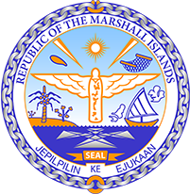

Republic of the Marshall Islands
STATEMENT byMr. Samuel K Lanwi Jr Deputy Permanent Representative
37th Session, Universal Periodic Review
18 January 2021
Geneva

Interactive Dialogue: Paraguay

Check against delivery

Thank you, Madam President.

The Marshall Islands warmly welcomes the Delegation of Paraguay and thanks them for the comprehensive presentation of their third UPR report. We congratulate the Delegation for the achievements in the implementation of the recommendations from its previous cycle.

The Marshall Islands offers the following recommendations for Paraguay’s consideration:
- Keeping in mind the rising global temperature and the role forests play in binding carbon dioxide we recommend curbing deforestation and implementing a forest restoration plan.
Additionally, we recommend strengthening environmental legislation and its implementation.

- Paraguay has been experiencing dramatic climate events which disproportionately affected indigenous people and women. Therefore, we recommend adopting a comprehensive national adaptation and mitigation plan for climate change, taking into account the views of all affected communities.

- We are worried about high rates of discrimination against indigenous peoples, particularly ongoing violations of their land rights and thus recommend creating a national action plan on indigenous people’s rights.

- We recommend ramping up efforts to protect women and children from gender-based violence and abuse, including through national awareness-raising campaigns to address the root cause of the issue.

We wish the Delegation all success during this third UPR cycle.

Kommol tata and thank you.

