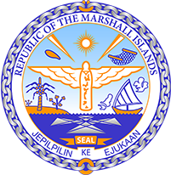

Republic of the Marshall Islands
STATEMENT by Mr. Samuel K Lanwi Jr. Deputy Permanent Representative
38th Session, Universal Periodic Review
3 May 2021
Geneva

Interactive Dialogue: Namibia

Check against delivery

Thank you, Madam President.

The Marshall Islands welcomes the Delegation of Namibia and thanks them for the presentation of their third UPR report. Namibia deserves recognition for being among the top protectors of human rights in its region and we would like to encourage Namibia to continue on this path. With a view to further improve the human rights situation in the country we offer the following recommendations:

- While efforts to address gender-based violence are welcomed, we see that these don’t take the desired effect and therefore recommend taking more targeted measures to address the root causes of gender-based violence, and introducing a budget for implementation.
- We recommend formally recognizing the rights of indigenous communities in the Constitution so as to ensure their specific needs are safeguarded. On particular aspect is the issue of land expropriation, which we recommend to be addressed comprehensively.

We wish the Delegation all success during this third UPR cycle.

Kommol tata and thank you.

