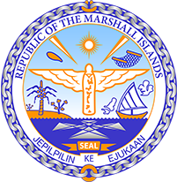

Republic of the Marshall Islands
STATEMENT by Mr. Samuel K Lanwi Jr. Deputy Permanent Representative
38th Session, Universal Periodic Review
5 May 2021
Geneva

Interactive Dialogue: Belgium

Check against delivery

Speaking time: 55 seconds

Thank you, Madam President,

The Republic of the Marshall Islands warmly welcomes the delegation of Belgium and thanks them for their report.

We commend Belgium on its efforts towards improving the rights of disabled persons, including through the establishment of measures regarding their employment.

We are pleased to note the efforts made to improve child rights, including the measures taken to combat violence against children. We particularly welcome the focus on eradicating child poverty included in the Federal Anti-Poverty Plan.

We offer the following recommendations for Belgium’s consideration:
- Establish clear human rights-based criteria to ensure that the Paris Agreement targets are implemented.
- Develop a national plan of action to reduce greenhouse gas emissions
- Take additional measures to increase the employment rate of persons with disabilities, especially disabled women.
In closing, we wish the delegation of Belgium every success during this third UPR cycle.

Kommol tata and I thank you.

