Jamhuuriyadda Federaalka Soomaaliya  Ergada Joogtada Soomaliyeed ee Qaramada Midoobey ee Geneva | 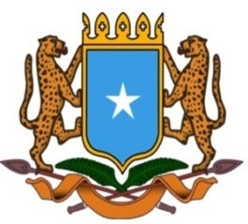 | جمهورية الصوما ل الفيدرالية  البعثة الدائمة لجمهورية الصومال بمكتب الأمم المتحدة بجنيف وبالوكالات المتخصصة بسويسرا

Permanent Mission of the Federal Republic of Somalia to the United Nations Office at Geneva and other International Organizations in Switzerland

Check Against Delivery
Statement by the Delegations of Somalia,
Mr. Hussen Abdi Musa, First Counsellor
at the Review of the Republic of Niger, during the 38th Session of the UPR Working Group on Monday, 03 May, 2021 from 2:30PM to 6:00PM, in the Assemble Hall of the Palais des Nations in Geneva, Speaker Number 84, Time: 1 minute 05 second.
Thank you Chair,

Somalia would like to warmly welcome the delegation of Niger to this cycle of the UPR working group and appreciates the comprehensive presentation of its national report.

We congratulate Niger for having accepted almost the recommandations received from the previous cycles and the significant progress made in their implementation despite enormous security and economic challenges. This outstanding result is a clear testimony of the political will and the commitment of the government to the UPR process.

We are also pleased to note that the National Human rights Commission has strengthened its status by adopting the Paris principles into its legal and policy framework and became a model in the subregion.

We encourage the government of Niger to continue its endeavors to further enhance human rights principles and values. In this regard we call upon international community to provide the assistance solicited by Niger in their national report.

Somalia recommends the following :

- To consider ratifying the protocol to the African Charter on Human and Peoples’ Rights on the Rights of Older Persons in Africa of 2016.
- To Provide the National Mechanism for combating trafficking in persons and illegal trafficking of migrant with the necessary human and financial resources for its effective operation.

We wish Niger a very successful review.

I thank you Chair.

