Jamhuuriyadda Federaalka Soomaaliya  Ergada Joogtada Soomaliyeed ee Qaramada Midoobey ee Geneva | 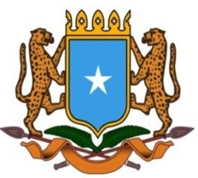 | جمهورية الصوما ل الفيدرالية  البعثة الدائمة لجمهورية الصومال بمكتب الأمم المتحدة بجنيف وبالوكالات المتخصصة بسويسرا

Permanent Mission of the Federal Republic of Somalia to the United Nations Office at Geneva and Other International Organizations in Switzerland

Check Against Delivery
Statement by the Delegations of Somalia,
Mr. Salah ABUBAKAR, Second Counsellor
at the Review of the Republic of Sierra Leone, during the 38th Session of the UPR Working Group on Monday, 12 May, 2021 from 2:30PM to 6:00PM, in the Assemble Hall of the Palais des Nations in Geneva, Speaker Number 94, Time: 1 minute 05 second.
Thank you Chair,

Somalia warmly welcomes the delegation of Sierra Leone to this cycle of the UPR working group, and appreciated the comprehensive presentation of its national report.

Somalia commends the efforts made by Sierra Leone to improve the situation of human rights since its last review through the implementation of the accepted recommendations, and also the adoption of a variety of legislation and policies. We particularly welcome measures taken by the government to preserve the human rights of its citizens during the state of emergency, in response to the outbreak of the covid-19 pandemic.
Somalia recommends:
- One, to continue efforts to strengthen policies and strategies to prevent social conflict and discrimination against minority,
- Two, intensify its efforts combating corruption and impunity, and ensure effective legal representation especially for the most vulnerable,
- Finally, to promote and protect the rights of the child by providing the necessary support to the National Commission for Children and also by increasing the budget allocated to the Ministry of Social Welfare, Gender and Children’s Affairs,
Somalia wishes Sierra-Leone, very successful Review.

I thank you Chair.

