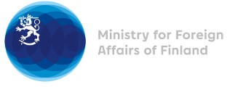

38 Session of the UPR working group Recommendations by Finland to Somalia

6 May 2021

Finland highly appreciates the engagement of Somalia in the UPR process and wishes to recommend the following:

- firstly, to adopt legislation prohibiting all forms of violence against women and girls in line with international law and to take concrete measures to end female genital mutilation, child, early and forced marriage, and all other forms of sexual and gender-based violence,
- secondly, to reform all the provisions of the Penal Code that violate the right to freedom of expression, and to protect journalists and human rights defenders from killings, arbitrary arrests, torture and ill-treatment and to bring those responsible to justice,
- thirdly, to ratify the Second Optional Protocol to the International Covenant on Civil and Political Rights aiming to the abolition of the death penalty.

I thank you.

