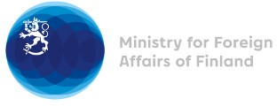

38 Session of the UPR working group Recommendations by Finland to Namibia

3 May 2021

Finland highly welcomes the engagement of Namibia in the UPR process and wishes to recommend the following:

- firstly, to take effective preventive measures to protect women and girls from discrimination and gender-based violence, especially sexual violence, and to ensure women’s and girls’ access to information on sexual and reproductive health and rights.

- secondly, to take concrete actions to ensure access to health services for LGBTI persons, especially transgender persons, and to combat all forms of discrimination against LGBTI persons in relation to employment opportunities and treatment by the police forces.

Thank you.

