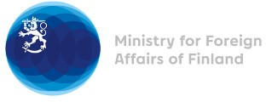

38 Session of the UPR working group Recommendations by Finland to Mozambique

4 May 2021

Finland highly welcomes the engagement of Mozambique in the UPR process and wishes to recommend the following:

- firstly, in line with Finland’s previous recommendation, to implement gender related legislation and the gender strategy in education in order to combat female illiteracy, gender-based violence and child, early and forced marriages, and to establish state-funded shelters for victims of violence, particularly in rural and conflict-ridden areas,
- secondly, to facilitate human rights monitoring and media and humanitarian access to Cabo Delgado Province,
- thirdly, to strengthen the independence and impartiality of the judiciary and law enforcement institutions to ensure the right to a fair trial in line with international human rights standards.

Thank you.

