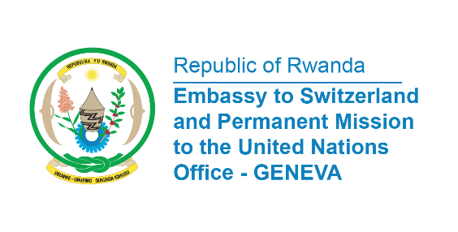

38th Session of the Universal Periodic Review Working Group
Review of Somalia
6th May 2021
Statement delivered by Ms. Marie Chantal Rwakazina, Ambassador and

Rwanda warmly welcomes the delegation of Somalia and thanks them for the Presentation of their National Report.
We take positive note of the commitments of Somalia to strengthen the protection of children affected by armed conflict and the progress in the fight against terrorist groups throughout Somalia.
Rwanda also commends Somalia for its reconciliation efforts including the development in March 2019 of the National Reconciliation Framework (NRF).

In a constructive spirit, Rwanda would like to recommend the following:

- Ratify the Convention against Discrimination in Education;
- Ratify the Convention on the Elimination of All Forms of Discrimination against Women;
- Speed up efforts to operationalize the National Human Rights Commission as accepted in 2016;
- Ensure that victims of violence, including those of sexual and gender-based violence, received holistic support and assistance.

My delegation wishes Denmark a successful review.

Thank you

