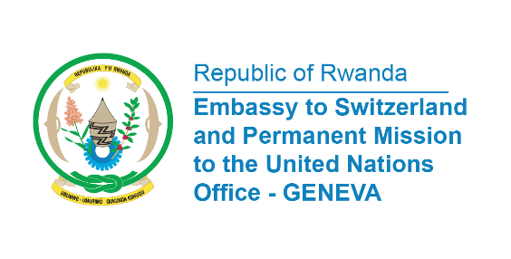

38th Session of the Universal Periodic Review Working Group
Review of Singapore
12 May 2021
Statement delivered by Ms. Marie Chantal Rwakazina, Ambassador and Permanent Representative of the Republic of Rwanda

Thank you, Madam President,
We warmly welcome the delegation of Singapore and thanks them for their comprehensive Report.
Rwanda commend Singapore for achieving universal healthcare coverage for all citizens.
We also commend Singapore for ratifying, in 2017, the International Convention on the Elimination of All Forms of Racial Discrimination.
Our recommendations are:
1) Continue efforts to eliminate discrimination against children in vulnerable situations;
2) Continue efforts to increase the participation of women in decision-making positions including in political and public life;
3) Continue efforts to address cases of gender-based violence against women, including domestic and sexual violence.

We wish Singapore a successful review.

