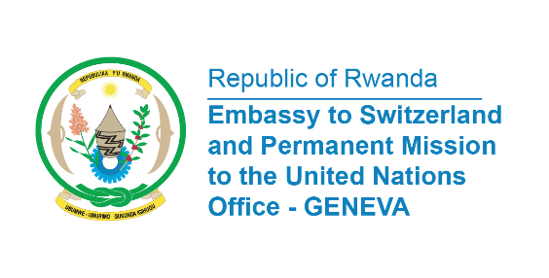

38th Session of the Universal Periodic Review Working Group
Review of Seychelles
10th May 2021
Statement delivered by Mr. Jean de Dieu, Communications & Multilateral Officer

Madame President,
We would like to extend a warm welcome to the delegation of Seychelles and thank them for their comprehensive National Report.
We welcome the enactment in 2020 of the Domestic Violence Act which prohibits acts of violence in the domestic context.
We commend the Government of Seychelles for adopting in 2018, the Seychelles Human Rights Commission Act establishing the Seychelles Human Rights Commission.
Rwanda also notes the launch in 2016 of the National Gender Policy to reinforce the government’s objectives to ensure gender mainstreaming.

In a constructive spirit, Rwanda would like to recommend the following:
- Ratify the Optional Protocol to the Convention against Torture and Other Cruel, Inhuman or Degrading Treatment or Punishment;
- Ratify the Convention against Discrimination in Education.

We wish Seychelles a successful review

Thank you

